

Deep Learning Methods for Seizure Detection
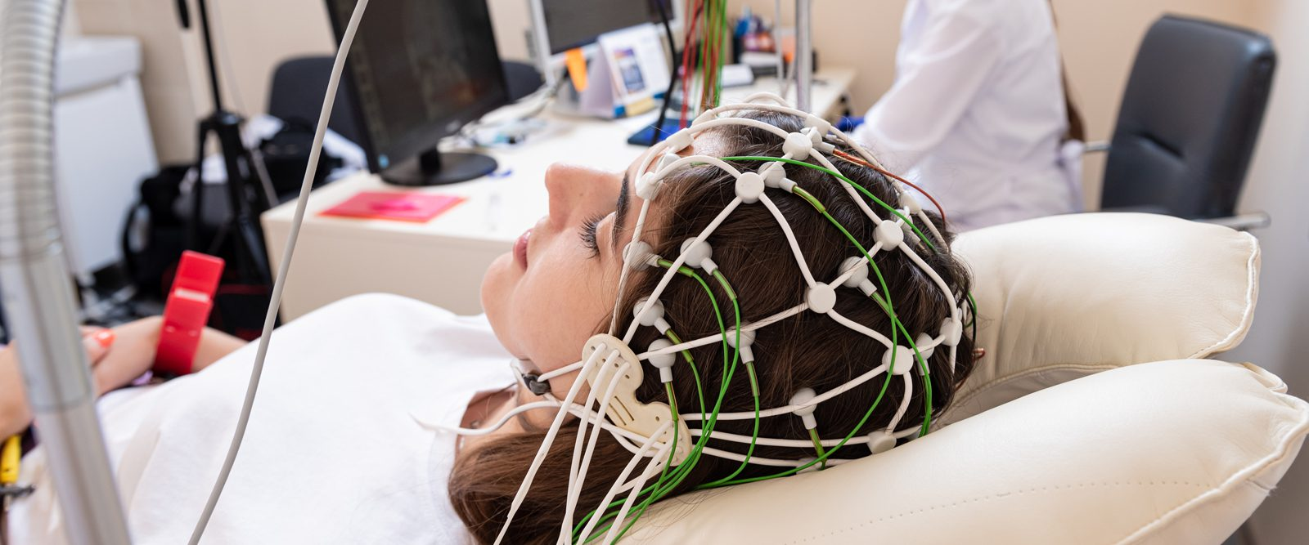

Submitted by:
Twyla Keating, 1770979
Zijian Li, 1781642
Enoch Shin, 1767565
Wenqi Zhang, 1785174

Deep Learning
26 March 2026

1. Introduction
According to the World Health Organization (WHO), epilepsy is a chronic brain disease affecting around 50 million people worldwide, with nearly 80% of people with epilepsy living in low and middle-income countries [2]. Epilepsy is characterized by recurrent seizures, which are episodes of involuntary movement caused by excessive electrical discharge in brain cells.
This drives a multitude of co-morbidities such as physical injuries (bruises, fractures, and the like), as well as psychological symptoms such as anxiety and depression. Moreover, the risk of premature death in people affected by epilepsy is up to three times higher than that of the general population, but the WHO estimates that up to 70% of people suffering from this condition could live seizure-free if properly diagnosed and treated [2].
Therefore, detecting and classifying seizure events in an automated and unsupervised fashion is an important and highly motivated task due to the potential for assisting millions of people in faster diagnosis and treatment.
In this report, we investigate the application of deep learning methods in the classification of epileptic seizures from normal brain activity using electroencephalographic (EEG) recordings. EEG is a non-invasive method for measuring neuronal electrical activity in the human brain cortex, defined by a set of N electrodes placed in various regions of the scalp. For each monitored patient, EEG recordings provide N temporal single-dimensional signals (i.e, one per channel). In the diagnostic process of epilepsy, a neurologist explores these EEG recordings visually to find patterns of spikes, sharp, and slow waves, that characterize an epileptic seizure.
Various techniques and methods have been explored and evaluated in existing studies to perform similar tasks in this context. Esmaeilpour et al.’s 2024 study in Engineering Reports examines existing literature for this task, noting that the data workflow typically involves three stages: noise removal, feature extraction, and feature classification [3]. Different methodology architectures are available for feature extraction and classification.
Starting with classical machine learning approaches, Support Vector Machines (SVM) classify data by finding an optimal decision boundary between classes in a high-dimensional feature space. In the context of EEG-based seizure detection, SVMs are typically applied not to raw signals but to handcrafted features extracted beforehand, such as those derived from wavelet transforms or frequency band power. While effective, this dependence on feature engineering means performance is tied to domain expertise in feature selection, as the approach does not learn representations directly from the data. Even so, SVMs have been employed to effectively classify between pre-ictal (before seizure) and interictal (stable state between seizures) states, being widely adopted in multiple academic studies investigating seizure prediction [3].
Additionally, Convolutional Neural Networks (CNNs) with channel fusion are considered a foundational technique for this task. CNNs learn hierarchical feature representations directly from raw or minimally processed input, making them well-suited for EEG signals where relevant patterns may not be obvious to human reviewers. Applied to multi-channel EEGs, CNNs use spatial convolutions to capture relationships across electrode channels and temporal convolutions to detect local patterns within the signal, which is a design exemplified by architectures like Lawhern et al’s widely-cited EEGNet [6]. A key design consideration is when to implement channel fusion, or in other words, when to integrate information across multiple channels. As discussed in Hernández-Sabaté’s study of EEG signals for measuring mental workloads of pilots, channel fusion can be done either early in the pipeline by treating the multi-channel input like a multi-channel image, or later, after per-channel features have been extracted independently [7].
Additionally, Long Short-Term Memory (LSTM) networks are designed to model sequential data by selectively retaining or discarding information over time through learned gating mechanisms. In other words, LSTMs are well-suited to EEG data because they can model the evolution of changes over time. According to Chakrabarti’s 2021 study on pediatric EEG seizure detection, LSTM methods are inherently more advantaged than other methods thanks to the ability to control what information needs to be kept in its memory and what must be removed, allowing for temporal information to be incorporated into the model [4]. In practice, LSTMs are often combined with a CNN backbone that first extracts features from each window, with the LSTM then processing sequences of those features across consecutive windows to capture longer-range temporal context.
Finally, transformers, which were originally developed for natural language processing, use self-attention mechanisms to model dependencies between all positions in a sequence simultaneously, without the sequential bottleneck of recurrent architectures [8]. In the context of EEG analysis, this allows the model to capture long-range temporal relationships across a signal in a single pass, and attention weights can in principle highlight which time points or channels are most relevant for a given classification. More recent work, such as Chen's 2024 Epilepsy Spiking Convolutional Transformer, has explored hybrid architectures that combine convolutional layers for local feature extraction with transformer encoders for global context, offering a balance between computational efficiency and representational power [9].

Goals
The main goal of this challenge is to train and evaluate deep learning models to distinguish between seizure and normal EEG data observations. Success in this investigation would be based on the accuracy and generalizability of our final model.
Within our main goal, there are two separate sub-goals for this investigation. First, we want to compare how our models perform with different data sampling windows:
- "Window level," where the data is split randomly across individual windows and serves as an optimistic upper bound on performance because the train and test windows could belong to the same seizure episode.
- “Seizure level," where entire seizure episodes are held out. This would allow us to test whether the model generalizes to new seizures within patients it has already seen during training.
- "Patient level," where all data from a given patient is excluded from training entirely, testing the model's ability to generalize to previously unseen individuals and representing the most clinically meaningful evaluation.
For our second sub-goal, we want to compare classification accuracy and performance with different modeling architectures. We approach this in two stages: first, a static classification baseline using a convolutional neural network that combines information across EEG channels and does not include temporal information; second, a temporal model that incorporates sequential context across consecutive windows using memory-based learning.

2. Methodology
First, we performed train-validation-test splits for the three different splitting methods of data (window, seizure event, patient), with two sampling modes (balanced 50/50 and unbalanced 20/80). More details about this splitting is discussed in Section 3.
For each of these three scopes of data, our methodology was to train classification models based on two architectures: the CNN and the Spiking Convolutional Transformer. For the first delivery of this project, we will focus solely on the CNN in this iteration of the report.
In this section, we discuss the data transformation pipeline and neural network architecture.

2.1 Step 1: EEG Processing and Normalization
The computational workflow begins by segmenting continuous raw EEG recordings into discrete 1-second windows. Because the data is sampled at 128 Hz across 21 electrodes, each input sample forms a two-dimensional array of 21 channels by 128 time-steps. Prior to classification, the raw voltage signals are standardized using z-score normalization. This normalization is applied independently to each of the 21 channels.
To strictly prevent data leakage, the mean and standard deviation required for normalization are calculated dynamically on a per-fold basis, using only the training data of the active split. Once normalized, these standardized arrays are passed to the 1D Convolutional Neural Network (CNN) for feature extraction and classification.

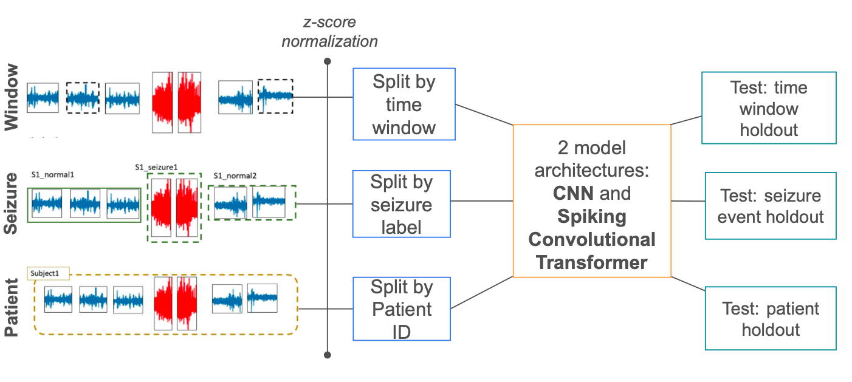
Figure 1: Overall workflow of our investigation. We show the three different data splits, and our two overall methods as the CNN and Spiking Convolutional Transformer.

2.2 Step 2, Channel Fusion 1D CNN
The primary classification engine is a 1D Convolutional Neural Network (CNN) designed to serve as a static performance baseline. The architecture directly ingests the normalized 2D arrays (21 channels by 128 time-steps) and immediately applies a 1D convolutional layer to execute "early channel fusion.”
The figure below summarizes the implemented CNN baseline from multichannel input to binary output.
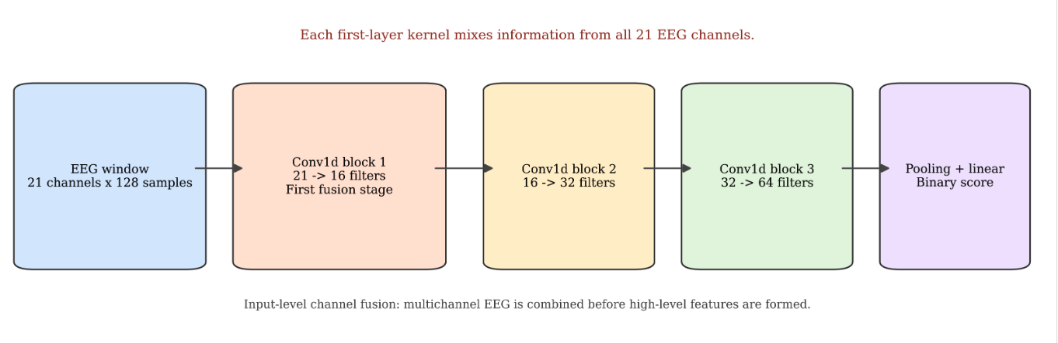
Figure 2. Summary of implemented CNN from multichannel input to binary output.

The first layer directly consumes all 21 EEG channels, the model already performs input-level channel fusion. This matches the challenge baseline and also clarifies that the temporal LSTM branch is not part of the current iteration of this report. This initial convolution integrates spatial information across all 21 EEG electrodes at the input level, allowing the network to learn spatial relationships simultaneously rather than processing each channel independently. Following this feature extraction, the resulting representations are routed into a standard fully connected classification head to produce the final binary prediction of either a "Seizure" or "Normal" state.
Importantly, this baseline architecture evaluates every 1-second window in isolation and operates entirely without temporal memory mechanisms, distinguishing it from the sequence-based models reserved for future deliverables.

2.3 Step 3, Spiking Convolutional Transformer
This model methodology will be reserved for the second submission of this project.

3. Experimental Design
At the start of our investigation, we performed train-validation-test splits for the three different splitting methods of data (window, seizure event, patient), with two sampling modes (balanced 50/50 and unbalanced 20/80).
First, we introduce the dataset.
3.1 Dataset Description
The data utilized in this study originates from the CHB-MIT Scalp EEG Database, encompassing continuous EEG recordings from 23 pediatric patients and one adult patient with intractable seizures.
The continuous recordings were down-sampled to 128 Hz and segmented into 1-second temporal windows, producing input arrays of 21 channels by 128 time-steps. To optimize model training, non-seizure windows are non-overlapping, while seizure (ictal) windows feature an 80% overlap for data augmentation.
Furthermore, to avoid transitional patterns, data windows within 30 seconds before or after a seizure event were discarded. The resulting dataset contains 571,905 discrete windows across 181 unique seizure events. The annotations provide binary ground truth labels indicating a normal state (0) or a seizure state (1), revealing a significant class imbalance of 485,233 normal samples (84.8%) to 86,672 seizure samples (15.2%).
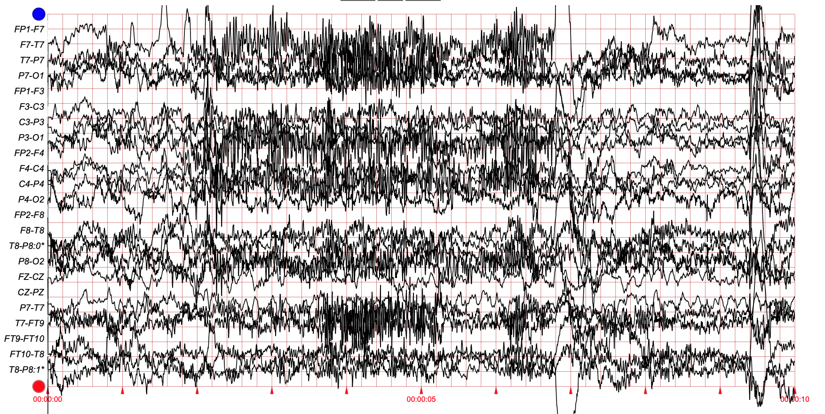
Figure 2. Sample observation from the dataset, chb01_01.

3.2 Partitioning and Sampling
We partitioned and modeled our data across three distinct cross-validation protocols, evaluating each under two training sampling modes: a synthetically balanced 50/50 class distribution and a realistically unbalanced 20/80 (seizure/normal) distribution. Moreover, we executed a 3 × 2 × 2 experimental design to systematically test how different real-world challenges affect the CNN's performance by comparing the 3 data partitions (Window vs. Seizure vs. Patient), against 2 training data modes (Balanced classes vs. Unbalanced classes) and 2 testing modes (Balanced vs. Unbalanced).
The three data partitioning strategies are defined as follows:
Window Level
At the window level, all individual EEG windows across all patients are pooled together and split into train, validation, and test sets using 15-fold cross-validation. In this configuration, the experimental sampling unit is the individual 1-second temporal window. First, the EEG signal windows are loaded from all patient-specific .npz files, alongside their corresponding metadata from the .parquet files. These are concatenated into a single, global dataset encompassing all available patient data. All 1-second EEG windows are randomly divided into 15 equal subsets. 14 are used for training, 1 for testing, repeated 15 times.
Note that the data has an 80% overlap during the ictal windowing, meaning each successive seizure window shifts by only 20% relative to the previous one, which produces many nearly identical windows from the same seizure episode. Because of this overlap, we will have highly similar windows from the same seizure episode in both training and test sets, this split does not guarantee independence between sets. As a result, we expect this to produce optimistically high performance results, so this level functions as an upper bound rather than a true measure of generalization.
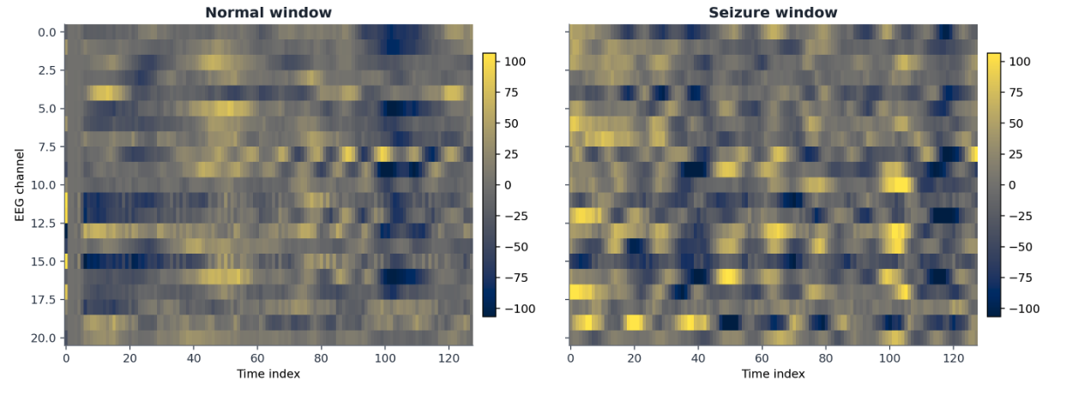
Figure 3. Sample observation from the dataset. The left panel shows a normal window, and the right shows a seizure window. Each input is a 21-by-128 multichannel EEG segment.
In the figure above, we illustrate a comparison of a normal versus seizure window. This makes the baseline challenge setup concrete: a single-window EEG classifier operating on the full multichannel matrix, and not on isolated single-channel traces.
Seizure Event Level
Using the .parquet metadata, specifically the global_interval identifier (which tracks unique seizure episodes consistently across all of a patient's recordings), the dataset is grouped by distinct events, either labeled as a non-seizure or seizure event.
During the data split, all overlapping 1-second windows belonging to a specific global_interval (a single seizure episode) are kept together and strictly assigned to either the training set or the test set. Here, we perform 181-fold cross-validation, where each of the 181 unique seizure events acts as its own test fold exactly once, while the other 180 are used for training.
By isolating entire seizure episodes rather than individual windows, this splitting strategy eliminates data leakage caused by the 80% window overlap. Consequently, the test set consists entirely of seizure and normal intervals not considered during training, providing a much more realistic evaluation of the model's ability to detect novel seizures in patients it has already been trained on. To further ensure a rigorous evaluation, the test set construction prefers drawing negative samples from completely normal recordings (recordings with zero seizure events). If a patient lacks a fully normal recording, the pipeline falls back to sampling from normal intervals within the mixed recordings.
Patient Level
The key consideration here is data leakage: we should be careful to split the train and test set to ensure that there is no overlap in patients in either set. Here, the experimental sampling unit is the individual patient, transitioning the evaluation from a personalized approach to a more generalized population-based model by training and testing by whole patients. Each of the 24 patients acts as the test fold once, while the data from the remaining 23 patients is used to train the model
Using the .parquet metadata, we group the EEG recording by subject using Patient ID or the patient identifier extracted from filename (e.g., chb01). During the data split, every temporal window (both seizure and non-seizure) belonging to a specific patient is strictly isolated into either the training, validation, or test set. This ensures a "leave-one-patient-out" evaluation, where no data from the test patients is ever exposed to the model during the training phase.
By entirely excluding specific individuals from the training set, this splitting strategy eliminates any patient-specific data leakage. It evaluates the model's capacity to generalize its learned features to completely unseen subjects. Consequently, it represents the most clinically realistic scenario, measuring true population-level performance rather than personalized, patient-specific anomaly detection.
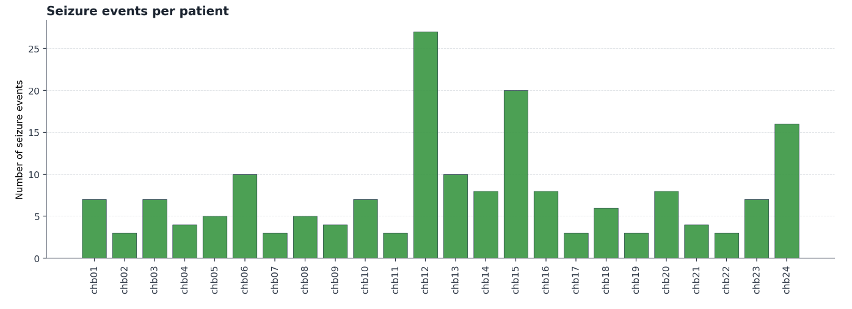
Figure 4. This figure summarizes how many seizure events are available for each patient.
In the figure above, we see that event availability varies substantially across subjects, which means within-patient generalization and cross-patient generalization are not the same problem. This directly matches the challenge distinction between seizure-event holdout and patient holdout.

3.2 Experiments and Metrics
The models were trained using PyTorch on UAB’s cluster, with the dataset distributed across 10 distinct shards to facilitate efficient data loading without memory failures. Model convergence was monitored during the training loop, and the weights yielding the highest performance were preserved via a checkpointing mechanism.
In the first portion of our experimental design, we inspected the model’s inner workings and discuss the training process and interpretability. In Section 4, Results, we display the training loss curves and discuss how the CNN utilizes the different channels of the EEGs.
Then, model performance is evaluated using a standardized set of classification metrics: Accuracy, Precision, Recall (Sensitivity), Specificity, F1-score, and the Area Under the Receiver Operating Characteristic Curve (ROC-AUC).
These metrics are derived from the confusion matrix components: True Positives (TP, correctly identified seizures), True Negatives (TN, correctly identified normal states), False Positives (FP, normal states misclassified as seizures), and False Negatives (FN, undetected seizures).
Accuracy is defined as the overall proportion of correctly classified windows, and its formula is the sum of TP and TN divided by the total sum of TP, TN, FP, and FN. Precision measures the proportion of predicted seizures that are true seizures, reflecting the model's resistance to false alarms; it is calculated by dividing TP by the sum of TP and FP. Recall, or sensitivity, is the proportion of actual seizures the model successfully detects, with a formula of TP divided by the sum of TP and FN. Specificity represents the proportion of actual normal states correctly identified—critical for our highly imbalanced dataset—and is computed by dividing TN by the sum of TN and FP. Finally, the F1-Score serves as the harmonic mean of precision and recall to provide a balanced metric for the 15.2% to 84.8% class imbalance, calculated as two times the product of precision and recall divided by the sum of precision and recall.
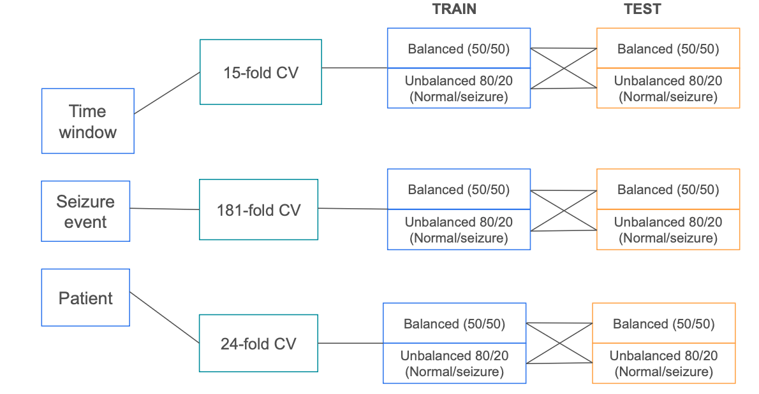
Figure 5. Data split defining the scopes, cross-validation, and sample balancing strategy along with train-test strategy. We execute a 3 × 2 × 2 experimental design to systematically test how different real-world challenges affect the CNN's performance by comparing 3 data splits (Window vs. Seizure vs. Patient), 2 training modes (Balanced vs. Unbalanced) and 2 testing modes (Balanced vs. Unbalanced)"

To evaluate and compare model performance across the various experimental configurations, we utilized a combination of descriptive statistics and visual summaries. Primary diagnostic plots generated by the pipeline include confusion matrices to assess class-level misclassifications and Receiver Operating Characteristic (ROC) curves to illustrate the trade-off between true positive and false positive rates. Additionally, the aggregated performance metrics (such as accuracy, precision, and F1-score) are compiled into comprehensive summary tables to facilitate direct comparisons across the different cross-validation folds and sampling regimes.

4. Results
This section presents (1) a dissection of the inner architecture and interpretable logic of the CNN model and (2) the evaluation results for the Channel Fusion 1D CNN baseline. We detail the model's classification performance across the three cross-validation protocols (window, seizure, and patient holdouts) under both balanced (50/50) and unbalanced (20/80) training distributions.
For each experimental configuration, we report various descriptive statistics (accuracy, precision, recall, specificity, F1-score, and ROC-AUC) to assess overall efficacy. To facilitate a robust comparison of the model's generalization capabilities, these tabular metrics are supported by diagnostic visualizations, including confusion matrices to highlight class-specific errors and Receiver Operating Characteristic (ROC) curves to illustrate prediction trade-offs. Furthermore, statistical tests and confidence intervals are incorporated to evaluate significant performance deviations across the different evaluation scopes and data sampling regimes.

4.1 Experiment 1: Explaining Underlying Channel Fusion 1D CNN
In this section, we dissect the inner architecture and logic of the CNN model to confirm correct implementation and interpretability. First, we see in the figure below that the CNN is effectively learning, as the training loss steadily decreases from 0.65 down to roughly 0.25 across the epochs. The loss decreases while the validation AUC rises and stabilizes, with some falloff towards the last epochs. This suggests that an earlier stoppage point could be beneficial.

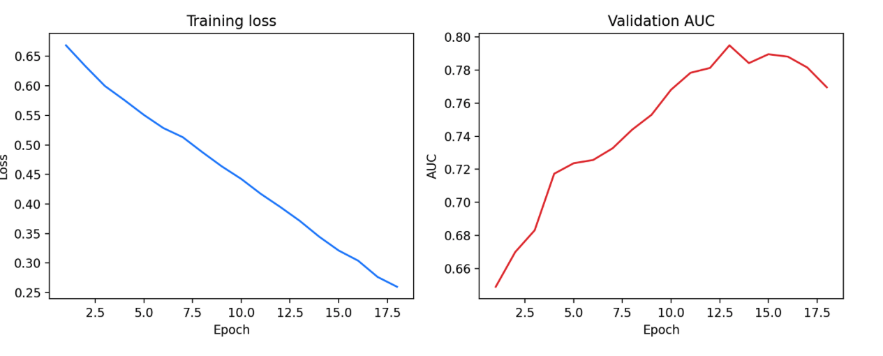
Figure 5. This figure shows the training loss and validation AUC trajectory for one representative outer fold.

Understanding the model’s usage of each channel in the EEG also provides insights into how the neural network relies on different aspects of the data. The heatmap below visualizes these insights into the model’s architecture:

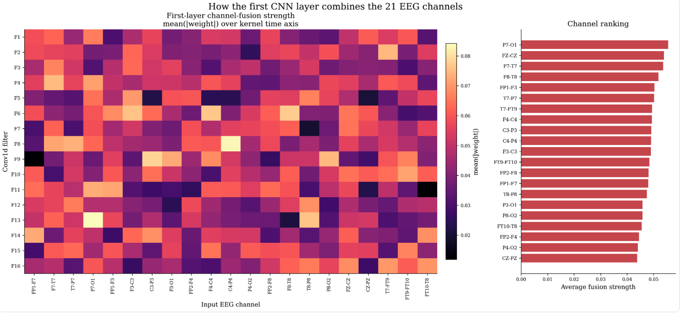
Figure 6. The heatmap summarizes how strongly the first convolutional layer uses each EEG channel, and the side plot ranks channels by average importance.

We see that the filters do not treat all channels equally, which suggests that the model is learning structured cross-channel combinations rather than a trivial uniform average. The plot on the right of the heatmap shows which channels had the most average importance. In general, this figure provides global evidence that channel fusion is actually happening.

4.2 Experiment 2: Evaluating the Channel Fusion 1D CNN
In this section, we evaluate model performance across the different split and sampling protocols. Recall that we executed a 3 × 2 × 2 experimental design to systematically test how different real-world challenges affect the CNN's performance by comparing 3 data splits (Window vs. Seizure vs. Patient), 2 training modes (Balanced vs. Unbalanced) and 2 testing modes (Balanced vs. Unbalanced).
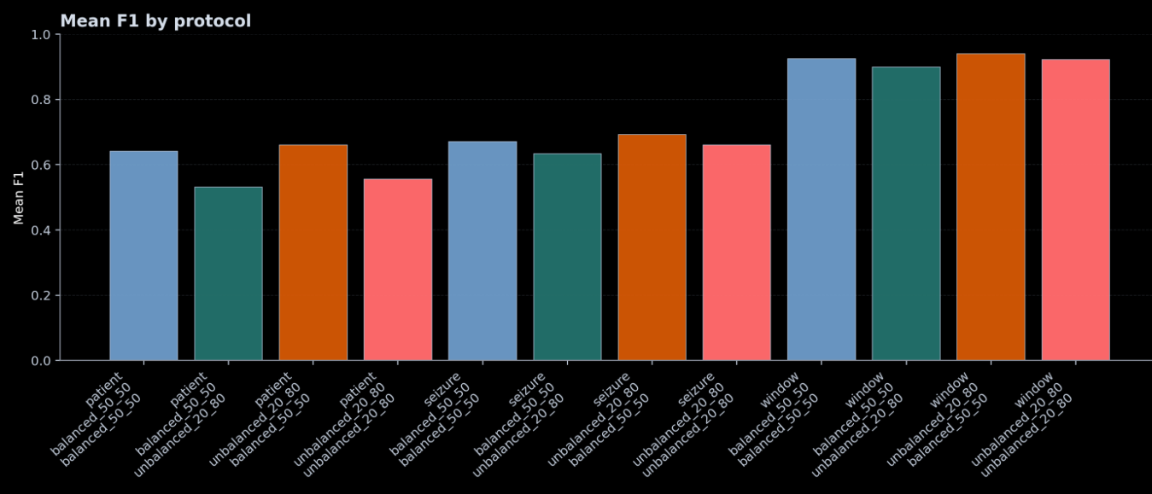
Figure 7. Bar chart compares mean F1 under the window, seizure, and patient protocols for all train/test sampling combinations.

The ordering is consistent with the challenge narrative that we expected in the beginning of this report: the time window holdout gives the upper bound of performance, seizure holdout is a personalized unseen-event setting, and patient holdout is the hardest population-level setting to model. The unbalanced test condition typically lowers F1, because it exposes the cost of false positives more realistically.

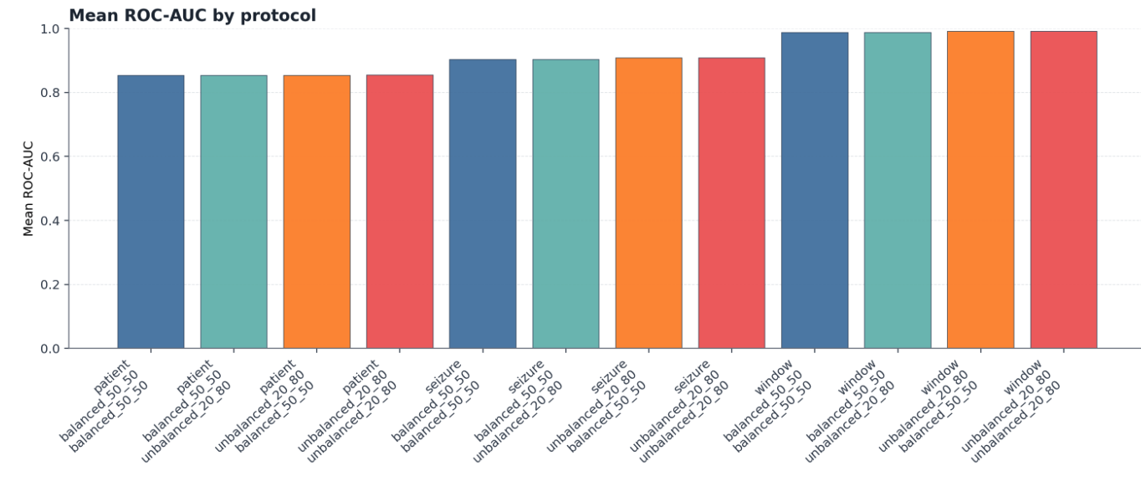
Figure 8. Mean ROC-AUC across protocols and sampling settings
This figure above reports the mean ROC-AUC for the same protocol and sampling matrix as the previous figure. The ranking pattern is similar to F1, but AUC is more stable. This suggests that the model still preserves useful ranking ability under harder protocols, even when the thresholded F1 score drops. In practice, this means class imbalance and threshold selection remain critical for deployment-oriented interpretation. Next, we report the F1 scores in all our sampling and split settings.
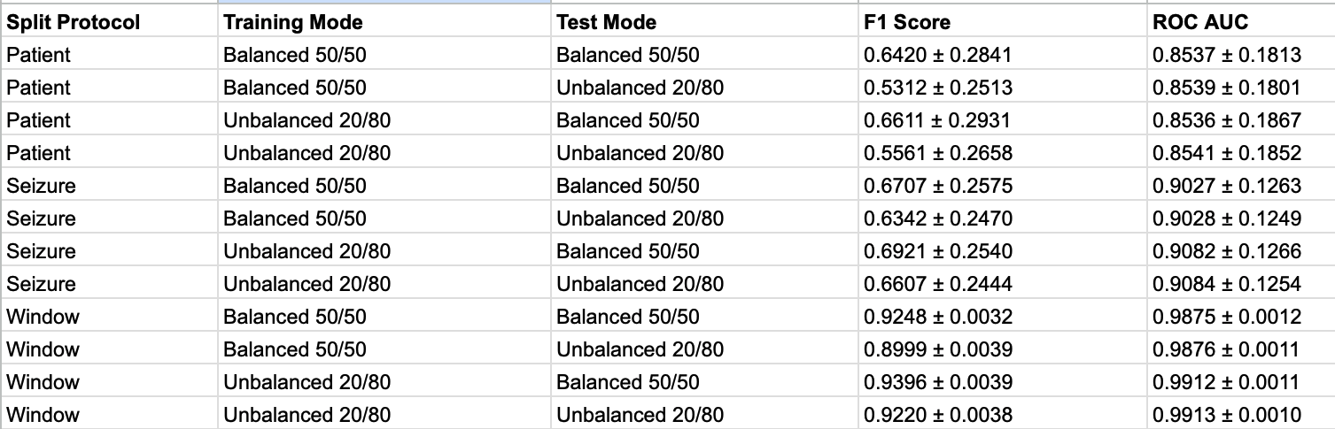
Figure 9. F1 score results of 3 × 2 × 2 experimental design with different combinations of training and test settings of balanced vs. unbalanced sets.

In the table above, the metrics validate our expectations about data leakage. The window split achieved massive F1 scores (~0.92) and near-perfect AUCs (~0.99) because the 80% window overlap allows the model to memorize seizures. When tested on unseen patients, performance drops drastically to an F1 of ~0.55 and AUC of ~0.85, representing the model's true real-world capability.
Moreover, for any pair of rows where the training mode is the same but the test mode changes (e.g., patient trained on balanced, tested on balanced vs. unbalanced), we see an interesting pattern. The ROC AUC stays virtually identical (0.8537 vs. 0.8539). However, the F1 score drops significantly (0.6420 down to 0.5312) on the unbalanced test sets. This proves that while the model's overall ranking ability (AUC) is stable, its precision plummets when it encounters the massive number of normal windows in the real-world (unbalanced) distribution, causing false alarms.
Finally, a common deep learning assumption is that we must balance the training data to help the model learn the minority class. However, looking at the hardest and most realistic scenario (patient split, unbalanced test), the model trained on unbalanced data actually achieved a slightly higher F1 score (0.5561) than the model trained on balanced data (0.5312). This indicates that preserving the natural distribution during training helped the model calibrate its threshold better for real-world predictions.
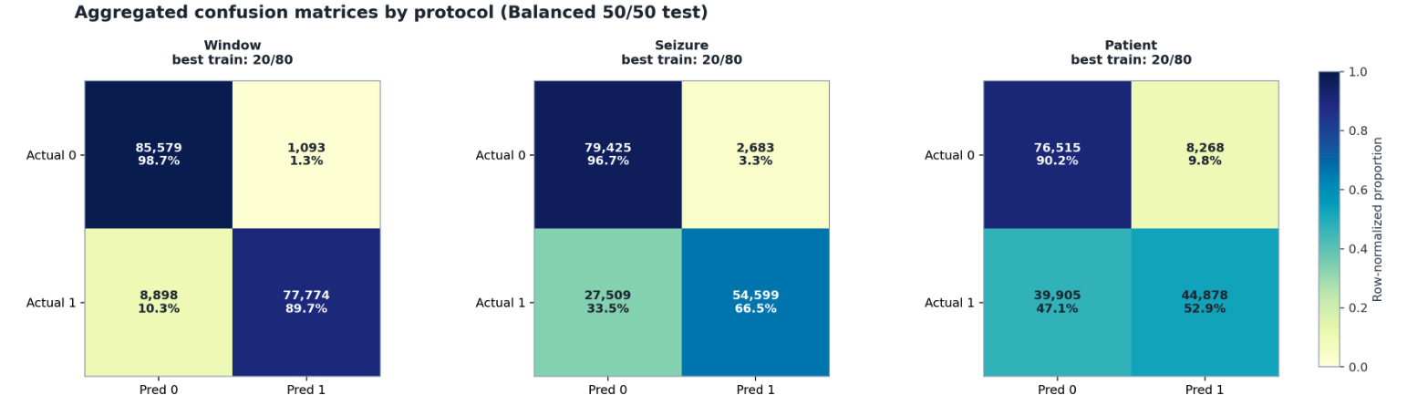
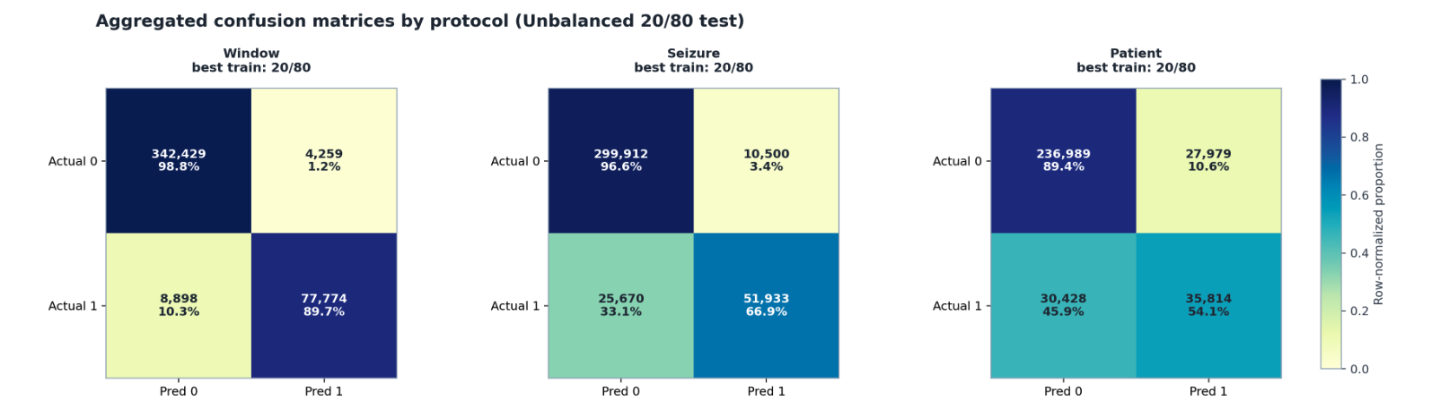
Figure 9. Protocol-wise aggregated confusion matrices on balanced and unbalanced test sets

Above, we see a comparison of confusion matrices for both balanced and unbalanced (80/20) test sets.
Under the balanced 50/50 testing setting, this figure selects the best train setting for each protocol and aggregates the confusion matrices across all outer folds. Each cell reports both the total count and the row-normalized proportion. Window holdout has the strongest diagonal, indicating the easiest generalization setting; seizure holdout is intermediate; patient holdout is hardest and mainly loses performance through reduced positive recall. This matches the intended challenge hierarchy of window > seizure > patient.
For the 80/20 unbalanced setting, because the negative class dominates, high specificity becomes visually tied to a large true-negative block, while the recall-versus-false-positive trade-off becomes more deployment-relevant. For seizure and patient holdout especially, this view better exposes trustworthiness under realistic class ratios.

5. Discussion and Conclusions
In this study, we evaluated a 1D Convolutional Neural Network for EEG-based seizure detection across three distinct cross-validation protocols to understand its performance under varying degrees of generalization.
The window-level holdout protocol served as our optimistic upper bound due to the inherent data leakage caused by the 80% overlap in ictal windowing. Under this constrained setting, the model achieved its highest performance. Specifically, training on an unbalanced (20/80) distribution and testing on a balanced (50/50) set yielded a peak mean F1 score of 0.9396 and a mean AUC of 0.9912. The fully balanced configuration (50/50 train and test) reached an F1 of 0.9248 and an AUC of 0.9875, while the fully unbalanced configuration (20/80 train and test) maintained strong performance with an F1 of 0.9220 and an AUC of 0.9913.
Moving beyond this upper bound, the seizure-level holdout evaluated the model's capability in a personalized clinical setting, measuring its ability to detect novel seizure events within patients it had already observed during training. Finally, the patient-level holdout provided the most rigorous and clinically realistic evaluation by testing true population-level generalization on completely unseen subjects. As expected, performance metrics declined as the holdout conditions became more stringent and realistic.
This progression highlights the critical importance of evaluating seizure detection models on independent, patient-level data splits to accurately gauge their real-world diagnostic utility before clinical deployment.
For next steps, we intend to implement temporal architectures. The current 1D CNN evaluates each 1-second EEG window in strict isolation, ignoring the sequential nature of brain activity. Implementing recurrent architectures, such as an LSTM, or self-attention mechanisms, such as a Spiking Convolutional Transformer, would allow the model to track the evolution of a signal over time. This temporal memory could help the model distinguish between a true seizure and a brief, normal artifact.

6. References
[1] Fishman, Levi. “What to Expect in an Epilepsy Monitoring Unit.” NewYork-Presbyterian, 10 Nov. 2023, https://healthmatters.nyp.org/what-to-expect-in-an-epilepsy-monitoring-unit/.
[2] Epilepsy. https://www.who.int/news-room/fact-sheets/detail/epilepsy. Accessed 12 Mar. 2026.
[3] Esmaeilpour, Ali, et al. “Deep Learning‐based Seizure Prediction Using EEG Signals: A Comparative Analysis of Classification Methods on the CHB‐MIT Dataset.” Engineering Reports, vol. 6, no. 11, Nov. 2024, p. e12918. DOI.org (Crossref), https://doi.org/10.1002/eng2.12918.
[4] Tsiouris, Κostas Μ., et al. “A Long Short-Term Memory Deep Learning Network for the Prediction of Epileptic Seizures Using EEG Signals.” Computers in Biology and Medicine, vol. 99, Aug. 2018, pp. 24–37. ScienceDirect, https://doi.org/10.1016/j.compbiomed.2018.05.019.
[5] Chakrabarti, Satarupa, et al. “A Channel Independent Generalized Seizure Detection Method for Pediatric Epileptic Seizures.” Computer Methods and Programs in Biomedicine, vol. 209, Sept. 2021, p. 106335. ScienceDirect, https://doi.org/10.1016/j.cmpb.2021.106335.
[6] Lawhern, Vernon J., et al. “EEGNet: A Compact Convolutional Network for EEG-Based Brain-Computer Interfaces.” arXiv:1611.08024, arXiv, 16 May 2018. arXiv.org, https://doi.org/10.48550/arXiv.1611.08024.
[7] Hernández-Sabaté, Aura, et al. “Recognition of the Mental Workloads of Pilots in the Cockpit Using EEG Signals.” Applied Sciences, vol. 12, no. 5, Feb. 2022, p. 2298. DOI.org (Crossref), https://doi.org/10.3390/app12052298.
[8] Vaswani, Ashish, et al. “Attention Is All You Need.” arXiv, 2017. DOI.org (Datacite), https://doi.org/10.48550/ARXIV.1706.03762.
[9] Chen, Qinyu, et al. Epilepsy Seizure Detection and Prediction Using an Approximate Spiking Convolutional Transformer. 2024. DOI.org (Datacite), https://doi.org/10.48550/ARXIV.2402.09424.

